EXPT NO:4 | Visual encoding of data
DATE: 20.01.2026 | Visual encoding of data

PRE-LAB QUESTIONS
- How does the human visual system process visual variables?
Ans - The human visual system quickly notices visual features like color, size, shape, and position to identify patterns and differences in data.
- Why is improper encoding misleading in analytics?
Ans - Improper encoding can distort data patterns, causing users to misunderstand trends and make incorrect decisions.
- What are perceptual limitations in visualization?
Ans - Humans have difficulty accurately judging small color differences, similar shapes, and overlapping objects.
- How does color choice affect interpretation?
Ans - Color choice influences how data is perceived, as strong or dark colors draw more attention and can suggest higher importance.
- Why should AI dashboards be perceptually optimized?
Ans - Perceptually optimized dashboards help users easily understand AI outputs, reduce confusion, and improve trust in AI decisions.
OBJECTIVE: To apply effective visual encoding principles for meaningful data communication.
SCENARIO: A city traffic department analyzes accident data to identify high-risk zones and accident severity patterns.

IN-LAB TASKS (Using R Language) • Encode severity using color gradients • Represent accident frequency using size • Use shape to indicate accident type

CODE:
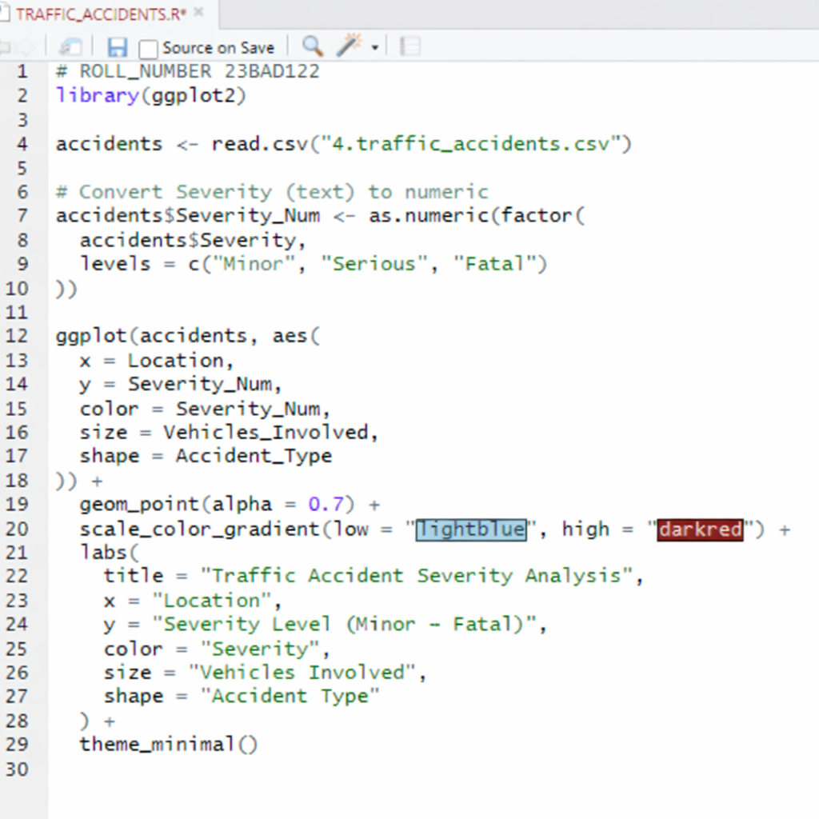

OUTPUT:
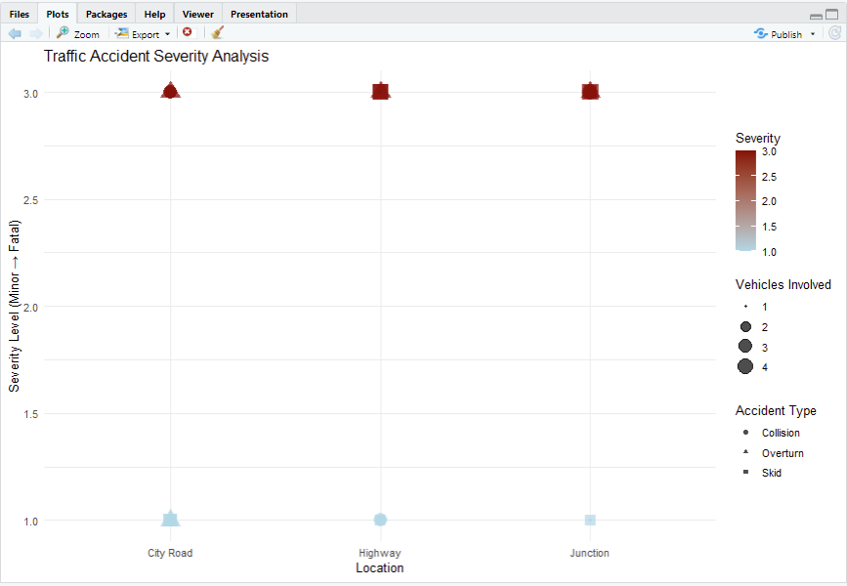
POST-LAB QUESTIONS
- Which visual variable best conveys severity and why?
Ans - Color gradient best conveys severity because darker colors immediately indicate higher accident severity (Fatal) and lighter colors indicate lower severity (Minor).

- How can poor encoding mislead policy decisions?
Ans - Poor encoding can hide high-risk areas or make low-severity accidents look serious, leading to wrong safety planning and resource allocation.

- What precautions should be taken for color-blind users?
Ans - Use color blind friendly palettes and combine color with size, shape, or labels so severity is not shown by color alone.
- How does visual encoding affect AI explainability?
Ans - Clear visual encoding helps users easily understand patterns found by AI, making AI decisions more transparent and explainable.
- Suggest improvements for large-scale public dashboards.
Ans - Add filters, interactive legends, clear labels, and tooltips so users can explore accident patterns across locations and severity levels.

LEARNING OUTCOME: Students learn perceptually effective visual communication for AI systems.

ASSESSMENT
Description | Max Marks | Marks Awarded
Pre Lab Exercise | 5
In Lab Exercise | 10
Post Lab Exercise | 5
Viva | 10
Total | 30
Faculty Signature

